
Symbiosis Institute of Technology, Pune
CSE- Academic Year 2026-27
Java Programming – Lab Batch 2025-29
Lab Assignment No.: 19
Name of Student | Akshit Gawade
PRN No. | 25070122029
Batch | 2025-2029
Class | A1
Academic Year & Semester | Second Year  Semester III
Date of Submission
Title of Assignment: | Develop a Java application to establish connectivity with a database and perform data retrieval using the SELECT operation.
Problem Statement  &  Learning  Objective | Problem Statement  Develop a Java application to establish connectivity with a database and perform data retrieval using the SELECT operation.  Learning Objectives  To establish database connectivity and retrieve records using JDBC SELECT statements.
Theory | Java Database Connectivity (JDBC) is a standard Java API that enables communication between Java applications and relational databases. It provides a platform-independent mechanism to connect to databases  such as MySQL, Oracle, PostgreSQL, and SQL Server. Before executing SQL statements, a JDBC driver is loaded and a connection is established using the DriverManager class. The Connection object represents an  active connection to the database, while the Statement object is used to execute SQL queries. The SELECT statement retrieves records from database tables based on specified conditions. The retrieved records are stored in a ResultSet object, which allows sequential access to the data. JDBC simplifies database programming and is widely used in desktop, web, and enterprise applications.
Program Code | Main:  import java.sql.*;  public class Main {  public static void main(String[] args) {  String url = "jdbc:mysql://127.0.0.1:3306/college";  String user = "root";  String password = "P@resh123!";  try {  Class.forName("com.mysql.cj.jdbc.Driver");  try (Connection con = DriverManager.getConnection(url, user, password);  Statement stmt = con.createStatement();  ResultSet rs = stmt.executeQuery("SELECT * FROM student")) {  System.out.println("Student Records:");  while (rs.next()) {  System.out.println(  rs.getInt("id") + " " +  rs.getString("name") + " " +  rs.getString("course")  );  }  }  } catch (Exception e) {  System.err.println("Database error: " + e.getMessage());  e.printStackTrace();  }  }  }  CODE SQL:  CREATE DATABASE college;  CREATE DATABASE shop;  USE college;  CREATE TABLE student (  id INT PRIMARY KEY,  name VARCHAR(50),  course VARCHAR(50)  );  INSERT INTO student VALUES  (1, 'Akshit', 'CSE'),  (2, 'Atharva', 'CSE'),  (3, 'Agam', 'CSE');  USE shop;  CREATE TABLE product (  product_id INT PRIMARY KEY,  product_name VARCHAR(50),  quantity INT,  price DOUBLE  );  INSERT INTO product VALUES  (101, 'Pizza', 15, 250),  (102, 'Burger', 25, 120),  (103, 'Pasta', 12, 180);
Output Screenshots | 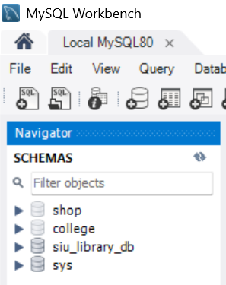  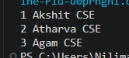
Exercise Qns  and Code | - Create a Java application to display student records from database using SELECT query.  import java.sql.*;  public class Exp1 {  public static void main(String[] args) {  String url = "jdbc:mysql://127.0.0.1:3306/college";  String user = "root";  String password = "P@resh123!";  try {  Class.forName("com.mysql.cj.jdbc.Driver");  try (Connection con = DriverManager.getConnection(url, user, password);  Statement stmt = con.createStatement();  ResultSet rs = stmt.executeQuery("SELECT * FROM student")) {  System.out.println("Student Records:");  while (rs.next()) {  System.out.println(  "ID: " + rs.getInt("id") +  ", Name: " + rs.getString("name") +  ", Course: " + rs.getString("course")  );  }  }  } catch (Exception e) {  System.err.println("Error: " + e.getMessage());  e.printStackTrace();  }  }  }  2. Create a Java application that connects to a database and displays product details using a SELECT query. Show product ID, product name, quantity, and price.  import java.sql.*;  public class Exp2 {  public static void main(String[] args) {  String url = "jdbc:mysql://127.0.0.1:3306/shop";  String user = "root";  String password = "P@resh123!";  try {  Class.forName("com.mysql.cj.jdbc.Driver");  try (Connection con = DriverManager.getConnection(url, user, password);  Statement stmt = con.createStatement();  ResultSet rs = stmt.executeQuery("SELECT * FROM product")) {  System.out.println("Product Details:");  while (rs.next()) {  System.out.println(  "Product ID: " + rs.getInt("product_id") +  ", Name: " + rs.getString("product_name") +  ", Quantity: " + rs.getInt("quantity") +  ", Price: " + rs.getDouble("price")  );  }  }  } catch (Exception e) {  System.err.println("Error: " + e.getMessage());  e.printStackTrace();  }  }  }
Output Screenshots | 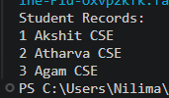  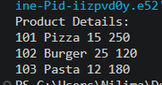
Conclusion | This experiment introduces relational database integration through Java Database Connectivity. It details establishing database connections via DriverManager and using Statement objects to execute SELECT queries, retrieving and parsing structured records line-by-line using ResultSet cursors.

